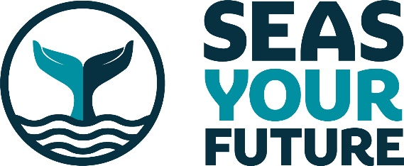
Sailing out of Lockdown Darwin style!
May 2021

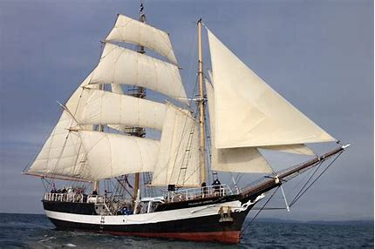

The Tall Ship Pelican of London sets sail from Folkestone on Monday 17th May on a 13-week voyage sailing all around the UK. In the summer of 2020, the ship was chartered by Darwin 200 in preparation for the Darwin200 voyage around the world following and recreating Charles Darwin’s journey on HMS Beagle, which was due to set sail in September 2021 (see www.darwin200.com).

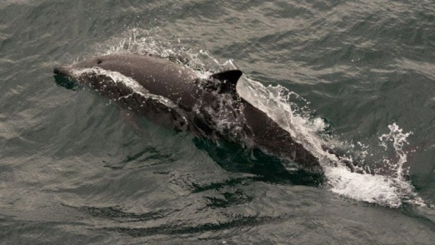
Due to Covid19 restrictions the round the world voyage has been postponed, so, as a result of the successful round UK voyage in 2020, Darwin200 has again chartered Pelican of London to circumnavigate the UK in the Spring and Summer of 2021. This will give the Darwin200 team, working with Seas Your Future, the opportunity to offer more young people the excitement of Sail Training on a Tall Ship, and the chance to undertake Ocean Science investigations while visiting the most spectacular and interesting islands in the British Archipelago!

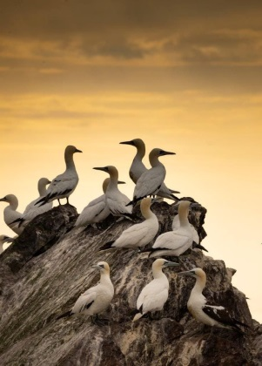
Between stops in ports around the UK’s coasts, we will sail to the most beautiful corners of the British Isles. We will explore breath-taking lochs and pass dramatic castles. We will land (where possible) to see circles of ancient standing stones, and (weather-permitting) the abandoned villages of the mysterious island of St Kilda. Our team of young scientists will undertake science projects in UK waters following an ocean study plan designed for this voyage by Charlotte Braugardt for Seas Your Future, and making use of a TriLux fluorescence sensor on loan from Chelsea Technologies as a new instrument for Ocean Science Data Logging which is easy to operate, no-nonsense data logging and seamless plug-and-play with laptops. The scientists will gather data on the health of the ocean, and enjoy observing countless common dolphins, harbour porpoises, many bottle nosed dolphins, great numbers of sunfish, blue fin tuna, a basking shark, several minke whales and immense seabird colonies, including tens of thousands of northern gannets on the spectacular Bass Rock.

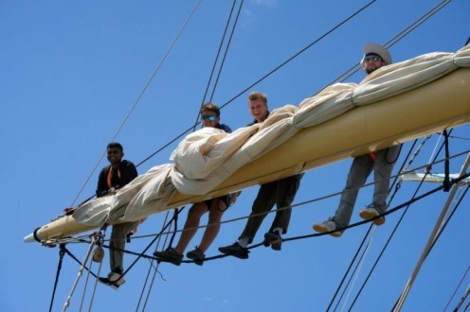
From observing sunsets from the deck, to seeing dolphins in the bow wave, they’ll leave this voyage with memories that they will never forget. But it is not a luxury cruise though! Sailing Pelican of London is an incredible experience. All voyage crew take part in sailing activities, including night watches, helm, look out, and assist with navigation. Through this unique, intense, challenging, all weather, round the clock learning experience, young people rapidly build their self-reliance, confidence, resilience, leadership skills and a positive mental attitude which will help chart their futures.

A rigorous strategy is in place to prevent Covid-19 being contracted by any participants of the UK Voyage. This strategy worked extremely effectively during our 2020 voyage, during which no Covid-19 cases arose whatsoever. All participants will be tested for Covid-19 prior to commencement of the UK Voyage. Temperatures will be taken on a daily basis for the first 14 days of participation. Protocols will be in place throughout the voyage, to ensure we undertake this journey Covid-19 free.

Seas Your Future CEO Adrian Ragbourne said, “This voyage with the Darwin 200 team, with whom we worked so successfully last year, is offering fantastic opportunities to around 60 young people to experience the fun and challenges of sailing a tall ship, make new friends, experience great teamwork, and take part in some very important scientific analysis of the waters around our beautiful British coastline. Sailing at this time of year will present them with a real mix of British weather in all its forms!”

You can follow their progress via the Seas Your Future website and regular social media posts.

Notes for Editors
Seas Your Future (SYF) – www.seasyourfuture.org – is a UK charity which owns and operates the tall ship Pelican of London primarily as a sail training vessel for young people, in the northern hemisphere during the spring and summer months around the UK and Europe, and during the autumn and winter months on a six-month transatlantic educational voyage. We meet our core objectives through:

- Sail Training programmes enabling young people to discover their abilities, values, passions and responsibilities in situations that offer adventure, challenge and the unexpected.
- unique Maritime Careers opportunities to learn about life on-board, safety at sea, seamanship, navigation, engineering, teamwork and much more.
- voyages for studying Ocean Science, changes to the marine environment and climate, to young people who care passionately about safeguarding the planet.
- ensuring that voyages are open to all young people by seeking to subsidise costs for those that cannot pay.
- Expanding sail training capacity and specialist voyages over the next five years, to meet increasing demand.

The ship has berth capacity for up to 35 trainees and 12 crew and volunteers and has been undertaking sail training voyages since 2007. We aim to sail for 48 weeks every year and our sailing programme is normally agreed 12-24 months in advance. We work in strategic partnership with charities and community organisations, education providers, vocational trainers, port authorities and local councils, to offer a unique and life-changing experience to all who sail with us. Despite the global pandemic, since July 2020 we have successfully delivered 34 weeks of covid-safe sail training voyages.

The full sailing itinerary can be read here:

https://www.seasyourfuture.org/wp-content/uploads/2021/03/Darwin200-2021-UK-Voyage22.pdf

A series of short videos from last year’s voyage can be seen on Youtube here:

https://www.youtube.com/playlist?list=PLaZWAxQE-o8b3h_7uAZmY5TskOBxc4fPf

Contact Simon Thorrington - simon@seasyourfuture.org – for more.

